***The PA Governor’s Jobs1st STEM Competition***

***Bishop Shanahan High School***

***2016 Regional Competition Project Plan***

**“CODE BLUE: HOMELESS RESCUE INITIATIVE”**

**Stephen Anderson, Angela Herb, Matthew Horger, Andrew Johnson, Conor Waldt**

Advisor: John Janasik, Ph.D.

**Proposal**:

Through the use of real-time GPS coordinates, Google Maps Application Program Interface (API), and temperature sensors, we hope to create a prototype that can be implemented into carts which assists authorities and social services in finding the homeless to provide shelter for them during freezing conditions, while maintaining the utmost privacy of the user. Our device will increase awareness of health conditions during harsh weather and aid in addressing the challenges homeless populations face. In all, our device will make homeless populations safer, their protection more efficient and ultimately prevent suffering and save lives.

**Real World Problem**:

**On any day, 16,200 Pennsylvanians are known to be homeless**. In Chester County, approximately 684 are homeless. During one school year, school districts around the state provide services to approximately 13,000 homeless children. Philadelphia’s poverty rate, 27%, is one of the highest in the nation, resulting in a high density homeless population. This problem extends beyond Pennsylvania and is a pressing issue across the country. One major concern with the homeless is finding shelter, especially in freezing conditions. Unfortunately, some homeless people do not go to the shelters and sleep outside in the frigid temperatures. This possesses a serious risk of frostbite as well as potential death from hypothermia. We intend to solve this issue with our prototype. Every additional person we can help locate and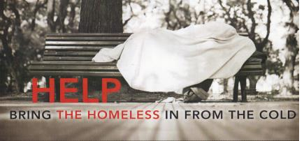

|  |  |  |
| --- | --- | --- |
| find shelter is a potential life saved. With our device, this is a tangible reality. |  |  |
| BSHS Project Plan – 2016 PA Governor’s JOBS1st STEM Regional Competition | Page 1 |



**Background Research Information (B.R.I):**

From December to March, the Office of Supportive Housing (OSH) assisted by the Department of Behavioral Health (DBH) may issue a **Code Blue**. This alert is announced when winter conditions become harmful to the health of those outside in the cold. Typically, these conditions are freezing temperatures or wind chills less than twenty degrees Fahrenheit. The OSH may also call a **Code Grey** during high winds, heavy rain, or frozen precipitation when the temperature is above freezing. Both **Code Blue** and **Code Grey** follow the same notification procedure; the Office of Court Compliance (OCC) will alert those in charge of finding the homeless and report the locations of shelters where the homeless may stay. These places are the first and best option; however, public buildings and police stations may be made available as alternative shelters if necessary. This method ensures the homeless have the opportunity to stay indoors as long as the alert is active. Our device aims to enhance this already implemented system. Locating the homeless and communicating between authorities and shelters is essential to effective execution.

**Identification of a Community Need:**

1. The population of homeless in Pennsylvania often struggle in finding warm shelter during cold, winter nights

2. Providing a more effective way of bringing the homeless inside during **Code Blue** and **Code Grey** conditions by authorities and social services

3. Despite shelter resources across the nation, the number of the unsheltered homeless remains a severe issue

**Risks and Safety Information**:

We will communicate with Social Service personnel throughout the entirety of our project to ensure the legality and appropriateness of our device. By doing so, we will be aided by people knowledgeable of the concerns and limitations when working with the homeless. By obtaining a human consent form (ACLU), this will help us to honor the rights and privacy of the homeless.

**Budget Documentation ($500):** (see attached budget sheet and copies of receipts)

BSHS Project Plan – 2016 PA Governor’s JOBS1st STEM Regional Competition Page 2

**Procedure:**

1. Create the **Arduino circuit** using the **GPRS** and **temperature modules**. Insert **SIM card** in our GPRS so the module can send coordinates.

2. Program and upload the **Arduino sketch** to the prototype. Attach the rechargeable battery module to the prototype

device.

3. Secure prototype device in encasement.

4. Install **Linux.** Linux is an operating system. Install **Python 2.7.** Python is a scripting language that will allow our

TCP server to run.

5. Install **MySQL**. MySQL is a database language which will store our latitude and longitude coordinates.

6. Install **Plone** along **Zope**. Plone is a content management system integrated into a web interface.

7. Import MySQL Database into Plone.

8. Integrate **Google Maps API** into Zope.

9. Install **ZMySQLDA.** This is a SQL Database Adapter that Zope will use to talk to our SQL database.

10. Create web page and **DTML** insertion methods. Open the webpage - power the device. A marker will appear on the map indicating where the device will be.

**Experimental Testing:**

To test our prototype, we shall first test the GPRS functions by having two team members walk around a local neighborhood, two more members monitoring the server, and one member retrieving the initial two members in a car. To test the temperature sensors, we shall wait for a freezing night and place the device outside to register a reading and

send a signal to the server. Information and statistics will be gathered.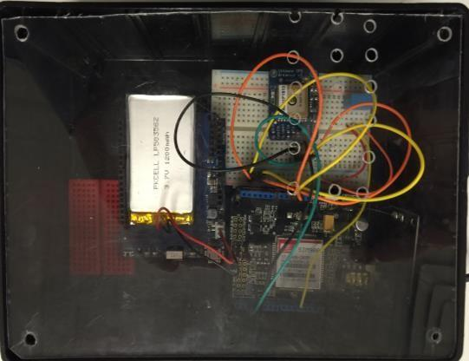

**The Prototype DEVICE includes:**

**1. Arduino Board**

**2. GPRS Shield w/ SIM Card**

**3. GPS Breakout Module**

**4. Temperature Module**

**5. Connection Wires**

**6. Lithium Battery**

**7. Device Box**

**8. GPS Active Antenna**

BSHS Project Plan – 2016 PA Governor’s JOBS1st STEM Regional Competition Page 3

**Costs of Improvement:**

To improve the project we would:

1. Design and build a better encasement for the current device. If the current device is used, a waterproof, more secure, tamper proof encasement system would be designed and implemented.

2. Investigate and implement the process of making the device potentially wearable. Wearable materials would range from $40-$50 dollars per square yard.

3. Explore and design the making the prototype device smaller by making a printed circuit board (PCB). The cost range would be from $50-$200 dollars.

4. Make improvements to the battery capacity.

5. Design and build a durable cart that would: securely contain the device, provide the user with a good deal of functionality, and be portable enough to enable the police and other rescue personnel to quickly pick up and transport the cart and user to safety.

a. Security of the system would be the biggest concern. We would implement a tamper-proof circuit that would detect a break in the electrical circuit, which will send the coordinates and a warning to the server. Costs of this circuit will start at $350.

b. The inclusion of a “Panic Device” to enable the cart user to contact rescue personnel in case of an emergency.

c. The functionality aspect would include additional materials to help the user maintain dignity, cleanliness, and personal safety.

**Future Application**:

Pennsylvania, and in particular Philadelphia, is unfortunately prone to a great number of homeless living in the streets. In a wider scope, the amount of homeless across the nation is also growing. With our device, we would like to reach out to shelters across the East Coast, helping them to effectively provide the homeless with tools for a safe, secure, and dignified life.

|  |  |  |
| --- | --- | --- |
|  |  |  |
| BSHS Project Plan – 2016 PA Governor’s JOBS1st STEM Regional Competition | Page 4 |



**STEM Professions Required for Actual Product:**

***AutoCAD Specialists*** to draw final designs of the encasement

***Computer Engineers*** to analyze the server functions and program the Arduino sketch ***Electrical Engineers*** to design and create the security circuit for the prototype ***Material Scientists*** to research encasement materials and potential wearable fabrics ***Mechanical Engineers*** to design and build an effective cart.

**Corporate/Agency Connections and Partners:**

**1. Communications Test Design Inc**

1334 Enterprise Dr, West Chester PA · (610) 436-5203

**2. Safe Harbor of West Chester**

20 N Matlack St, West Chester, PA 19380 · (610) 692-6550

**3. Decade to Doorways**

601 Westtown Rd., Suite 365, West Chester, PA 19380 (610) 344-6900

**4. ConnectPoints**

Rei Horst, ConnectPoints Program Director - (610) 696-1999 x142

**5. Covenant House of PA**

31 E Armat St, Philadelphia, PA 19144 – (215) 951-5411)

**6. ACLU of Pennsylvania**

PO Box 60173, Philadelphia PA 19102 – (215) 592-1513)

**Works Cited:**

**"Chester County Find Resources." *ConnectPoints*. 2016. Web. 16 Dec. 2015.**

**"Code Blue." *PHILA.GOV | Welcome to the City of Philadelphia*. Web. 08 Oct. 2015.**

**Cowart, Melinda, and Ron Cowart. "Pope Francis Reminds Us to Shelter the Homeless." *TheHill*. Capitol**

**Hill Publishing Corp., 07 Oct. 2015. Web. 09 Oct. 2015.**

**"Decade To Doorways." *Preventing and Ending Homelessness*. 2010 Solutions, 2016. Web. 16 Jan. 2016. "Facts on Homelessness." *Project HOME*. Project HOME, 2016. Web. 09 Jan. 2016.**

***Issues | Housing Alliance of Pennsylvania*. Housing Alliance of Pennsylvania, Web. 08 Oct. 2015.**

**"This Interactive Map Shows How Each State Stacks Up In Terms Of Homelessness." *Movoto Blog*. Movoto**

**LLC., 2014. Web. 08 Oct. 2015.**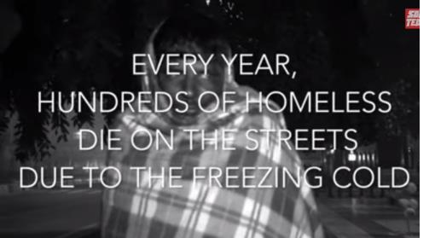

**Thompson, Christie. "What Happens To The Homeless When They Die." *ThinkProgress*. CENTER FOR AMERICAN PROGRESS ACTION FUND, 26 June 2014. Web. 09 Oct. 2015.**

***Bishop Shanahan High School***

***2016 PA Governor's JOBS1st STEM Regional Competition***

**BUDGET**

**“Code Blue: Homeless Rescue Initiative”**

**Stephen Anderson, Angela Herb, Matthew Horger, Andrew Johnson, Conor Waldt**

Advisor: John Janasik, Ph.D.

|  |  |  |  |  |
| --- | --- | --- | --- | --- |
| ***QUANTITY*** | ***ITEM / SOURCE*** | ***PURPOSE*** | ***RECEIPT #*** | ***COST*** |
| **1** | **ARDUINO Mega 2560 R3 (Amazon)** | **Micro Controller - Main Prototype Board** | **9** | **$37.77** |
| **1** | **SEEED GPRS Shield 2.0 (Radioshack))** | **TCP/IP (Internet) Connection with Arduino** | **2** | **$47.67** |
| **1** | **Adafruit Ultimate GPS Breakout (Adafruit)** | **GPS Coordinate Logger Module** | **7** | **$39.95** |
| **1** | **DHT11 Temperature & Humidity Sensor (Adafruit)** | **Real Time Temperature Readings** | **8** | **$5.00** |
| **1** | **Adafruit PowerBoost 500 Shield (Adafruit)** | **Rechargeable Power Module** | **7** | **$19.95** |
| **1** | **Lithium Ion Polumer Battery (3.7v, 2500 mAh) ) (Adafruit)** | **Rechargeable Lipo Battery** | **7** | **$9.95** |
| **1** | **SIM Card (CVS)** | **Send Information Between Device &Sensor** | **4** | **$10.59** |
| **2 months** | **SIM Card Service (CVS)** | **Monthly Service Costs for SIM Card** **@$30.0****0/mo.** | **15** | **$60.00** |
| **1** | **Whitmore 6318 Utility Cart (Amazon)** | **Foldable Storage and Device Attachment** | **11** | **$35.76** |
| **1** | **Cart Liner (Amazon)** | **Protect Contents of Cart** | **11** | **$5.08** |
| **1** | **Arduino Wire Kit (Radioshack)** | **Wiring for Device to Modules** | **3** | **$7.41** |
| **1** | **Waterproof GPS Active Antenna 28dB Gain** | **Boost GPS Reception** | **14** | **$18.98** |
| **1** | **Project Box 7" x 5" x 3" (Radioshack)** | **Storage Box for Device** | **5** | **$7.49** |
| **1** | **Arduino Micro (Radioshack)** | **Backup data storage for the Device** | **5** | **$17.47** |
| **3 pks** | **Red Quick Mount Reflectors (Amazon)** | **Visibility of Cart at Night** | **12** | **$18.84** |
| **1 set** | **4 String Bags and Carabineers (Amazon/Home Depot)** | **Bags for Cart Accessories** | **10/1** | **$11.31** |
| **1 pkg** | **Hot Hands (Amazon)** | **Cart Accessory** | **12** | **$8.95** |
| **1** | **Flashlight (Hand Crank powered) (Amazon)** | **Cart Accessory** | **12** | **$8.99** |
| **1** | **Emergency Sleeping Bag (Amazon)** | **Cart Accessory** | **12** | **$9.23** |
| **1** | **Camp Towel (WalMart)** | **Cart Accessory** | **6** | **$3.97** |
| **2** | **First Aid Kit (Staples)** | **Cart Accessory** | **13** | **$.90** |
|  | **Additional S & H Charges and Taxes** |  | **4/7/12** | **$11.64** |
|  |  | **ALLOWABLE BUDGET** |  | **$500.00** |
|  |  | **TOTAL EXPENDITURES \*** |  | **$396.90** |
|  | * Receipts for all expenditures are attached | **REMAINING FUNDS** |  | **$103.10** |

|  |  |  |
| --- | --- | --- |
|  |  |  |
| BSHS Project Plan – 2016 PA Governor’s JOBS1st STEM Regional Competition | Page 7 |